Z91 Printing Mobile Handheld Android POS

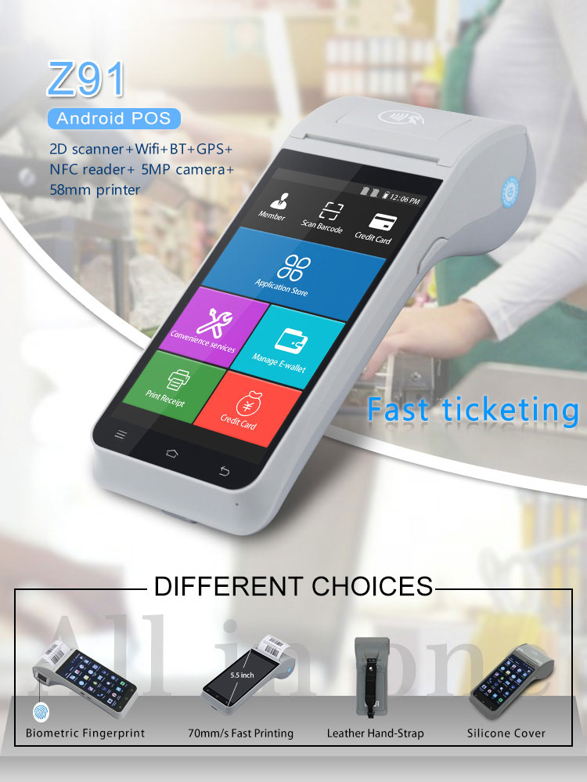

Introduction
Z91 4G Smart android POS machine, android 11.0 operating system, 5.5 inch screen touch, long standby battery capacity of 2800 mAh/7.4V, fast thermal printer, fingerprint collection module(optional), 5 MP camera, 2G/3G/4G/wifi/GPS/
bluetooth communication.
This fine workmanship and top quality machine is the best choice in the market.

Feature
- Android 11.0 operating system: adopt the open android system, can let the user a simple and efficient development of the upper application.
- Serviceable range : apply chain supermarkets, restaurants, Parking system, Prepaid airtime top up, convenience stores, clothing store, premises, bakery, cashier, pay, enters sells saves the business management function.

Technical Specification
Z91
Operating system | Android 11.0
CPU | Quad-Core Processor, 1.3GHz
RAM | RAM:2GB, EMMC: 16GB
LCD Screen | 5.5 inch
Display Resolution | 720*1280
Fingerprint collection  module(optional) | Spatial resolution :508 DPI  Active sensor area :12.8mm*18.0mm  (In compliance with FBI)
Communication | 4G/3G/2G/Hot spot/Bluetooth/WiFi(2.4GHz&5GHz)
GPS | Built-in GPS
USB | Type C USB(OTG),  Mini USB serial port
Camera | 5 MP rear camera with LED flashlight  Support 1D / 2D scanning
Card Slot | SIM ×2; SD×1(support SD 3.0, up to 128GB)
Touch screen | Capacitive touch screen, support the electronic signature
Charging indicator light | Single color LED
Printer | 70mm/s built-in high speed thermal printer,  58mm print paper,  40mm diameter paper roll
NFC card | Support ISO / IEC 14443 A＆B，Mifare，felica card，conform to EMV / PBOC PayPass standard (Optional)
GPS | Built-in GPS
Multimedia | Support for recording, voice broadcast  Support video play back/recording
Battery | Lithium battery, 2800 mAh/7.4V
Power adapter | Input:110V to 240V AC/50 ~ 60Hz  Output: 5V DC / 2 A  General Type C USB interface
Dimension and weight | 199.75mm x 83mm x 57.5mm,414g
Temperature | Storage temperature: -10℃-60℃  Working Temperature: 0℃-50℃
Standard Accessories | 1pc power adaptor,  1pc Type C USB cable,  1pc User Manual,  1pc Warranty card,  1 roll 58mm thermal paper,  1pc silicone case(optional)  1pc Hand Belt(optional)
Certificate | FCC,CE,CCC

